Assignment 5

## Socket Programing UDP

* 4. Try to get your partner’s IP address and make your client send a message to his/her server. Are you able to send the message? If no, why is that? What do you need to do to make it work? Support your answers with screenshots.
* A client is able to send a message and receive the message back from the server in uppercase.

* Server is able to receive a message from the client and send back the information in uppercase to the client

My program was able to run all the requirements from the lab.\

Instructions for Users

## Step1: Save the files UDPClient.java and UDPServer.java on your computer

## Step2: Find your programs location and on the path location type cmd to open the command prompt with the location of your programs.

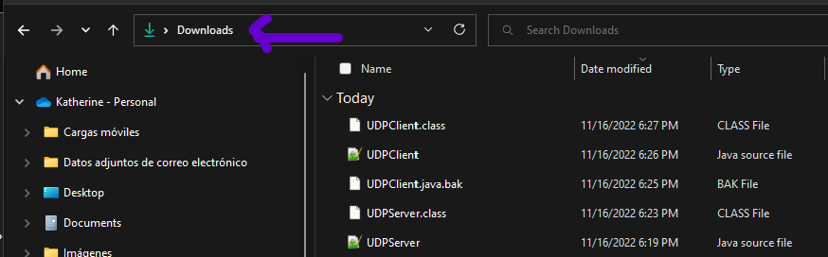

Click there and write cmd

## Step2: the command prompt should appear in your computer

## Step3: Click on the + sing to add another window if you are going to run both programs on your local machine and another one to find your IP address

Note: if you are going to run just the server or client from your computer and the other program on another you don’t need to add another console, so you are going to need just two consoles.

## Step4: run the following command on each of your consoles

Console1: javac UDPClient.java

Then -> Java UDPClient

Console2: javac UDPServer.java

Then -> java UDPServer

Console3: ipconfig

## Step5: Console1: Ipv4 address from console3 or “localhost” with no space to use your same computer. And also write the port number that the server is using. The default server port number is 9900

## Step6: write the message and wait for the echo or your message back in uppercase. In this scenario, the server will receive your message and send it back to your client.

Note: you will be able to send multiple message to the server or type “end” to close both programs